|  |
| --- |
|  |
| Demonstration and Evaluation of Webpage Concept |
|  |
|  |
| **Brian Willis – C12331591** |
|  |

|  |
| --- |
|  |

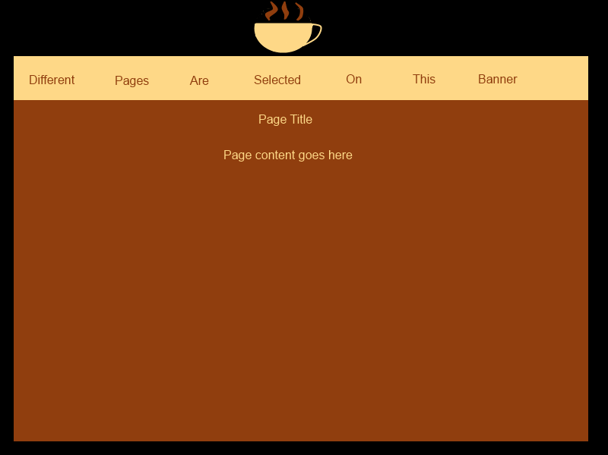

**Concept for a “Coffee Café” webpage**

This design should make for an appealing look for the site and also should hopefully allow simple navigation.

**Evaluation with Nielsen’s Heuristics**

**Visibility of system status:** Each page will be clearly titled at the top. This should make it clear to the user where they are in the site.

**Match between system and the real world: As a website, this will not feature a great deal of technical language, sticking instead to an ordinary, informative style which users should grasp easily.**

**User control and freedom:** All pages will be accessible from the navigation bar at the top of the site, which is consistent between pages. This means that should a user access the wrong page, they will easily be able to correct their mistake.

**Consistency and standards:** The site will retain a uniform layout across different pages, allowing consistency between them. The interface will be simple and familiar, with content at the centre and with the navigation bar above.

**Error prevention:** The concept does not call for any elements which are likely to cause site errors or require special measures to prevent them. The simple navigation interface should help to minimalise user error.

**Recognition rather than recall:** All related information will be available on the same page and all related inputs will be available at the same time. This means the site will not have to rely on the user’s recollection of other information or inputs.

**Flexibility and efficiency of use:** The design of this concept is straightforward and quick enough that it should be well suited to both novices and experienced users. Page access will be well labelled, assisting novices, while navigation will still be fast enough so as not to slow down more experienced users.

**Aesthetic and minimalist design:** This concept uses uncluttered pages which will present information clearly to the user. The consistent and complimentary colour palette will hopefully make for an aesthetically pleasing site as well.

**Help users recognize, diagnose, and recover from errors:** There is limited scope in this concept for errors beyond user error, such as accessing the wrong page. In the event of such an error, the easily accessed navigation bar should allow for it to be rectified.

**Help and documentation:** The site should be sufficiently simple that it does not require additional documentation. Pages will be clearly labelled and any additional user input, such as filling in a form, will be clearly explained on its own page.